Services Provided Comments 24 10 2015

**I have attached or you a modified Services Provide excel sheet for better understanding:**

1. You have specified 7 services in top page of excel sheet shared above.

And in Category - "General Handyman" there are 13 services listed down in excel sheet.

Do we need to track only 7 services listed above?

* We have 6 main categories that will be shown in the **home** page which is the following:

1. GENERAL HANDYMAN

2. GENERAL MOVING

3. ASSEMBLE & Disassembly of FURNITURE

4. My deliveries (this is the one that was written in Arabic)

5. PERSONAL ASSITANT

6. RECEARCH & TUTORS SERVICES

1. **GENERAL HANDYMAN**

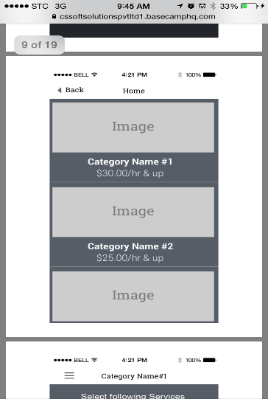

* When a client select handyman from the home page he will be directed to this page where he will see the 13 subservices to select from

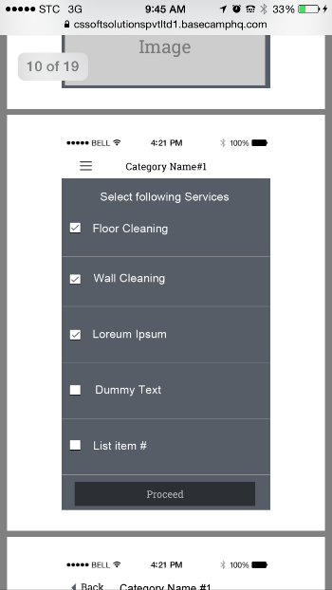

**When he select from the 13 sub services. For example PLUMING, HE WILL HAVE A SELCTION LIST OF THE SERVICES UNDER PLUMING T SELECT FROM SO IN HANDYMN ONLY WE WILL HAVE ONE ADDITONL STEP OF SELECTED THE THE BELOW PICTURE WILL SHOW.**

**THI SCREEN AGAIN:**



**(THE ABVE SCREEN IS REQUIRED IN THIS GENERAL HANDY MAN ONLY).**

**THEN THE BELOW SCREEN WILL BE SHOWN AFTER THE CLIENT COMPLETE HIS SELECTION**

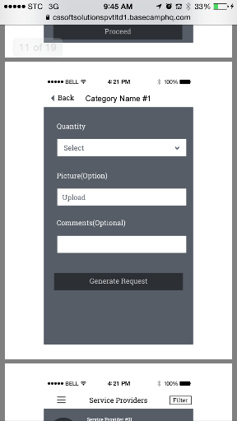

1. **GENERAL MOVING**
   1. **AFTER THE HOME CATEGORY PAGE WE WILL HAVE ONE SELECTION LIST OF SERVICES LIKE THIS PICTURE:**



**THEN**

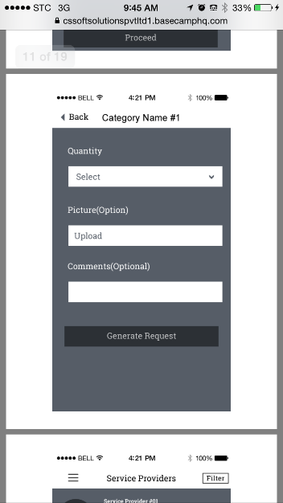

**ASSEMBLE & Disassembly of FURNITURE**

* 1. **AFTER THE HOME CATEGORY PAGE WE WILL HAVE ONE SELECTION LIST OF SERVICES LIKE THIS PICTURE:**



**THEN**



1. **My deliveries (this is the one that was written in Arabic)** 
   1. **AFTER THE HOME CATEGORY PAGE WE WILL HAVE ONE SELECTION LIST OF SERVICES LIKE THIS PICTURE:**



**THEN**



1. **PERSONAL ASSITANT**
   1. **AFTER THE HOME CATEGORY PAGE WE WILL HAVE ONE SELECTION LIST OF SERVICES LIKE THIS PICTURE:**



**THEN**



1. **RECEARCH & TUTORS SERVICES**
   1. **AFTER THE HOME CATEGORY PAGE WE WILL HAVE ONE SELECTION LIST OF SERVICES LIKE THIS PICTURE:**



**THEN**



2. We have "Task Duration per Visit" and "Task Minimum Duration Charge Per hour" mentioned in Category.

Is is there any possibility that we could have both fields for any category?

For hanyman only the cost will show and it will show next to it per vsit for example:

$30/visit

For the rest of the categories it will show next ot it per hour for example

$30/Hour

3. There will be below major category we will use as per excel sheet :

**1. GENERAL HANDYMAN**

**2. GENERAL MOVING**

**3. ASSEMBLE & Disassembly of FURNITURE**

**4.My order this is the one that was written in arabic**

**5. PERSONAL ASSITANT**

**6. RECEARCH & TUTORS SERVICES**

There is one missing that is listed in urdu after "ASSEMBLE & Disassembly of FURNITURE" in excel sheet provided. Please specify that. Is that **"My requests Services"** ?

No it is my orders

4. In "General Handyman" and "RECEARCH & TUTORS SERVICES" sub-service is properly defined. But in other category there is no sub-services.

Is that case that in other category we have direct sub-services and no categorization? Please specify.

As I have explained above, we have subservice in one category only which is the handyman, the rest will be category, they the services directly. So we will have an additional screen for subservices on handyman only.

Also there are Category in which no sub-services defined, do we need to ignore those like in "RECEARCH & TUTORS SERVICES".

I explained it above, only subservice for handy man as in handy man the client will have two screen of selections one to select the subservice and the second is to select the exact required service. For other categories we will have one screen to select the services from no subservice is there for now.

1. When Service provider register and opt for different services that we have listed above then how payment will get calculated, can you share one example so that it will get more clear.

The service providers can only select from the services which we have on the app, if there is other services that we don’t have he has to inform us and we will add it in the system so he can select it and input place him price to tat service.

However,

If the required service from the client is different from what have been selected they the employee, client, URFX admin, can make an additional expense charges,

The client can do it from the Khadamati page under current jobs,

The employee will have in his app an option to further invoice the client for additional work, he can add it as hours, or a fixed amount as agreed earlier.

**EXAMPLE**:

**I will share two examples one for handy man and one for orders**:

For handy man a client request the following service:

Plumping, and request to change a fucet,

The cost of the visit let’s say $30 per visit, and he want to replace 1 fucet. If there is additional work that the employee see it is chargable or the client request fro additional work during the employee is at their home, then additional charg can be done as per the below options:

* The client go to khadamati page, he click on the current job, then click pay additional amount, then e can input the value of the additional work.
* Also the employee can go in his app to additional charges page, and charge the client with a fixed amount.

**This is only for handyman as the price is per visit**

For research 7 tutors a client request the following service:

Request to English tutor.

The cost of the hour let’s say $50 per hour, and he want to 2 hours where that will show in the quantity he is inputting under quantity or he can write it as a comment. He will be shown the cost per hour once he agrees with a service provider, the client can go to current jobs and further charge the additional hours that they have agreed on or the employee can go and charge the additional charge they have agreed on.

In case if duplicate change the client will contact URFX admin and we will make the refund to their credit card from our side.

Any charges that shows per hour the employee can charge additional hours

Let’s say the client agrees on 2 hours of English tutoring and requested a certin book where the employee is going to buy for him, the employee can charge a fixed value for the book as well as that expense will be deducted from the client credit card as well.

**If you need any additional clarification please let me know.**